

FINAL PROJECT REPORT

DISCRETE MATHS

GROUP MEMBERS:

HAMZA RAZA (62381)

UMAIR MEHDI (61880)

TAHA KHAN (63646)

ANAS (62371)

HASNAIN TARIQ

CLASS I.D: 103347

SUBMITTED TO: Sir Farooq Zaidi

INTRODUCTION:

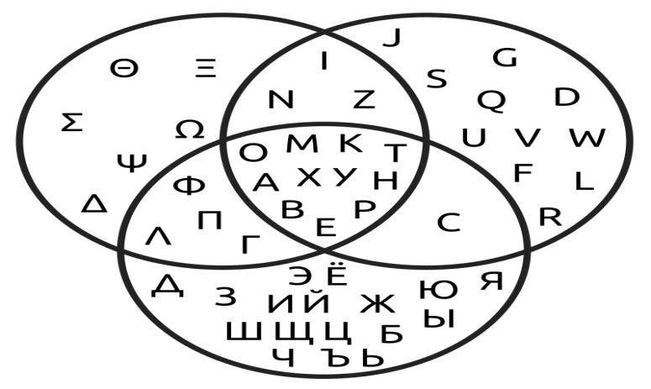

A **Venn diagram** (also called primary diagram, set diagram or logic diagram) is a diagram that shows all possible logical relations between a finite collection of different sets. These diagrams depict elements as points in the plane, and sets as regions inside closed curves. A Venn diagram consists of multiple overlapping closed curves, usually circles, each representing a set. The points inside a curve labelled *S* represent elements of the set *S*, while points outside the boundary represent elements not in the set *S*. This lends to easily read visualizations; for example, the set of all elements that are members of both sets *S* and *T*, *S* ∩ *T*, is represented visually by the area of overlap of the regions *S* and *T*. In Venn diagrams the curves are overlapped in every possible way, showing all possible relations between the sets. They are thus a special case of Euler diagrams, which do not necessarily show all relations. Venn diagrams were conceived around 1880 by John Venn. They are used to teach elementary set theory, as well as illustrate simple set relationships in probability, logic, statistics, linguistics, and computer science.

IMPLEMENTATION:

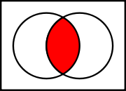

Intersection of two sets A ∩ B

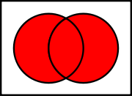

Union of two sets A U B

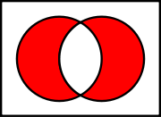

Symmetric difference of two sets A ∆ B

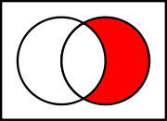

Relative complement of A (left) in B (right)

A ∩ B = B\A

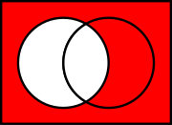

Absolute complement of A in U

A =U\A

A Venn diagram is constructed with a collection of simple closed curves drawn in a plane. According to Lewis, the "principle of these diagrams is that classes [orsets] be represented by regions in such relation to one another that all the possible logical relations of these classes can be indicated in the same diagram. That is, the diagram initially leaves room for any possible relation of the classes, and the actual or given relation, can then be specified by indicating that some particular region is null or is not-null".

Venn diagrams normally comprise overlapping circles. The interior of the circle symbolically represents the elements of the set, while the exterior represents elements that are not members of the set. For instance, in a two-set Venn diagram, one circle may represent the group of all wooden objects, while another circle may represent the set of all tables. The overlapping region or *intersection* would then represent the set of all wooden tables. Shapes other than circles can be employed as shown below by Venn's own higher set diagrams. Venn diagrams do not generally contain information on the relative or absolute sizes (cardinality) of sets; i.e. they are schematic diagrams.

WORKING:

1.When we put input number in the equation then it shows venn diagram.

2. When we put input number in the equation then it shows output.

3. When we will deactive a diagram so we will be able to use its points.

4. If we deactive any one diagram then all the other three diagrams will be active.

RESULT:

It will also help us in making students understand the venn diagram easily.